**ARTIFICIAL INTELLIGENCE**

**What’s AI?**

Artificial intelligence (AI) is the simulation of human intelligence processes by machines, especially by computer systems.

**Converting AI From Games to Real Life Problems**

**“...**basically, the models we implement to solve games are the same models we will implement to solve real world business problems or even any kind of general problems. That’s what we say in the video, you know. We need an environment on which we can train the AI on and that’s all the games, but then the models, if they work on the games, they’re very likely to work on real world environments or real world problems by only changing a few parameters.**”** [1]

**“OpenAI Gym”**

**“**OpenAI Gym is a website launched by entrepreneurs like Elon Musk and Peter Thiel, and basically they made such environments so that we can have some kind of benchmark for the AI models we implement. So that's an all-made environment, and we basically only need to implement an AI to test it and see if it can solve the games. If there wasn't an OpenAI Gym website, we would need to make the games ourselves. We would need to make all the games to find the environment, maybe making some map, defining the action. Well here, thanks to OpenAI, we don't have to do all these things. Everything is already well-prepared and we have some code to pre-process the images so everything is already ready, and we just need to implement the AI, and that's so cool because we can just focus on what's most important.**”** [2]

**Some AI Examples**

**The Google Example**

“...the Google example, how they use their AI. So the same team that built Alpha Go, they created an AI—we can only speculate that they used similar concepts—to optimize the electricity consumption in one of Google’s warehouses. They saved like 40% on energy consumption.”[3]

**JP Morgan Bank**

**“...**there’s another pretty exciting example, you know, the JP Morgan Bank. They made an AI that solved a specific task in one second whereas this task was solved by hundreds of lawyers and 3,000 hours or something like that. So, it basically solved a problem in one second that they usually solved in 3,000 hours.**”** [4]

**Reinforcement Learning**

“Reinforcement learning is the learning of a mapping from situations to actions so as to maximizes a scalar reward or reinforcement signal. The learner does not need to be directly told which actions totake, as in most forms of machine learning, but instead must discover which actions yield the most reward by trying them...”

**Q-Learning**

“Q-learning is at the base of reinforcement learning. Let’s try to explain in a few words what it is. Basically, Q-learning consists of learning Q-values. That sort of represents how well an action does in a specific state. So, for example, you have your environment, you’re going to play an action to reach the next state, and the Q-value represents how well this action did by being played in this state.

And then in Q-learning there’s no neural network yet because basically you’ve just learn this Q-function inside an equation, which is the Bellman equation, and iteratively you come to a better Q-value each time, making better actions and therefore solving the game or whatever the goal you want to accomplish.”

**The Bellman Equation**

V(s) = max(R(s,a) + γV(s’))

* s-State
* a-Action
* R - Reward
* γ - Discount

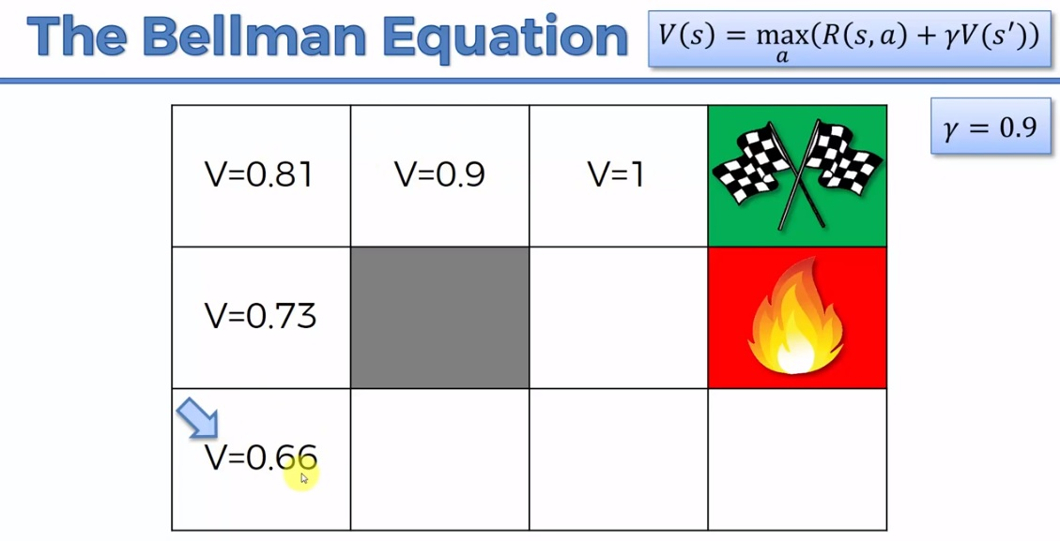

**Search Types**

**1.Deterministic Search**

Once an agent decides to do something, it justs do it. Nothing else is done. There’s no other options.

**2.Non-Deterministic Search**

When our agent dediced to do something, actually it may do some other stuff rather than the one it decided on. The actual point of this type of search is to make a more realistic world model. Actually this is where we simulate the possibilities, the randomness which is out of the control of the agent.

**Markov Process**

The possibilities or the values before the present state are not important. Just the present state and from then on is important in Markov Process (Property).

**Markov Decision Processes (MDPs)**

**“**Provides a mathematical framework for modeling decision making in situations where outcomes are partly random and partly under the control of a decision maker.” Actually this is the framework which our agents will use. By the use of this our Bellman Equation is just turns into the following form:

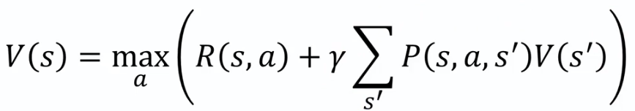

* **P(s,a,s’):** When you are in stage “**s**” the probability of going to state “**s’**” with the action “**a**”

The second part (the part multiplied by γ) actually represents the average of what we actually get into. It’s indeed coming from:

